Course Title: Anesthesiology and Intensive Care 1/2
WL-E6L4.AnesthIC
4 th year /6- year program/

II SEMESTER 2020/21

Coordinator /contact: Agnieszka Frączek-Gębczyk agnieszka.fraczek@uj.edu.pl

Responsible person/contact: Agnieszka Frączek-Gębczyk agnieszka.fraczek@uj.edu.pl
Prof. Janusz Andres, MD, PhD / msandres@cyf-kr.edu.pl

Address: Department of Anestesiology & Intensive Care
Kopernika 17 Street

Year: 4-6

Total number of hours: 40
Lectures: 13
Seminars: 12
Labs/Practicals: 15
Others (e.g. recitation): -
Exams:

Conduct/Dress Code: On intensive care units and surgical units, medical students are expected to dress; clean, neat doctor's uniforms and white changed footwear.
Students will not be allowed to enter the operating room unless they are wearing suitable protective clothing: scrub tops, scrubs pants and white, clean shoes /medical scrubs/.
Seminars -Practical Training on manikins:
Each students is expected to change footwear before every seminar.

Student’s Evaluation:
-credit requirements:
1. Passing the practical exam – exam based on clinical scenario. ALS, BLS skills.
Dates for each group listed in the tables below.
2. Written exam – test, after Anesthesiology and Intensive Care course on 5th year

-attendance requirements: 1. The presence at seminars -Practical Training /9 hours -obligatory/
2. The presence at seminars during Clinical Rotation /12 hours obligatory/
Each student is obligated to print a student’s attendance list available on the website, where teachers will sign every presence on clinical seminars. Any other form will not be accepted! (separate papers)
Attendance list should be taken back to the instructor/coordinator before the exam.

-type of the final exam: 1. Passing Practical Exam –oral and practical
-retake information: oral exam, scheduled individually

 | Day | Time | Type  of classes | N0 of hours | Group | Topic | Teacher | place
week  March 08 - 12 | Thu  March 11th | 16:00-17:30 | Lec. | 2 |  | Evaluation of the patient and preoperative medication.  General anesthesia.  Recovery from anesthesia, patients selection after recovery.  Anesthesia of elderly patients. | Prof. dr hab. J. Andres | Online :  Lecture will be posted on Pegazus  Consultaions for lecture on MS Teams at given date
week  March 08 - 12 | Thu  March 11th | 17:35-19:05 | Lec. | 2 |  | Anesthesia for children. | Prof. dr hab. K. Kobylarz
week  March 15- 19 | Thu  March 18th | 16:00-17:30 | Lec. | 2 | Whole class | ALS | Dr med. P. Krawczyk | Online :  Lecture will be posted on Pegazus  Consultaions for lecture on MS Teams at given date
week  March 15- 19 | Thu  March 18th | 17:35-19:05 | Lec. | 2 | Whole class | Regional anesthesia | Dr med. M. Kocot-Kępska
week  March 22-26 | Thu March 25th | 16:00-16:30 | Lec. | 2 | Whole class | Critical care in neurology and neurosurgery.  Seizures. Evaluation of the comatose patient. Brain death. | Dr.med A.Wrzosek | Online :  Lecture will be posted on Pegazus  Consultaions for lecture on MS Teams at given date
week  March 22-26 | Thu March 25th | 17:35-19:05 | Lec. | 2 | Whole class | Principles of mechanical ventilation | Dr med Krzysztof Zając
April 05-09 | Thu April 8th | 16:00-17:30 | Lec | 2 | Whole class | Obstetric anesthesia and pain relief in labour.  Long term catheters, venous, artery lines.  Infections in surgical patients-preventions, laboratory diagnosis, monitoring  -related bacteremia and sepsis.  Antibiotic prophylaxis in surgical theatres. | Dr A. Jastrzebska | Online :  Lecture will be posted on Pegazus  Consultaions for lecture on MS Teams at given date
April 05-09 | Thu April 8th | 17:35-19:05 | Lec | 2

Seminars – place: Center for Innovative Medical Education ul. Medyczna 7
Room: 1.11, 1.13, 1.17, 1.22

Wednesday
Date | Time | Group/ topic | Teacher
10.03.2021 | 16:00-18:30 | Airway management  Deteriorating patient (ABCDE approach)  Rhythm recognirtion | Lek. Tomasz Klimczyk
10.03.2021 | 16:00-18:30 |  | Lek. Katarzyna Rybczyk
10.03.2021 | 16:00-18:30 |  | Lek. Joanna Orzechowska
10.03.2021 | 16:00-18:30 |  | Lek. Rafał Świstek
17.03.2021 | 16:00-18:30 | High quality CPR and Defibrylation  Cardiac Arrest Simulations Teaching session – Bradycardia, Non-defib rythmes  Cardiac Arrest simulation Teaching session- Tachycardia, Defib rythmes | Lek. Katarzyna Rybczyk
17.03.2021 | 16:00-18:30 |  | Lek. Rafał Świstek
17.03.2021 | 16:00-18:30 |  | Lek. Tomasz Lonc
17.03.2021 | 16:00-18:30 |  | Lek. Joanna Orzechowska
24.03.2021 | 16:00-18:30 | Post- resuscitation care  Simulation Teaching Session  Simulation Teaching session | Lek. Rafał Świstek
24.03.2021 | 16:00-18:30 |  | Lek. Tomasz Klimczyk
24.03.2021 | 16:00-18:30 |  | Lek. Tomasz Lonc
24.03.2021 | 16:00-18:30 |  | Lek. Joanna Orzechowska
07.04.2021 | 16:00-18:30 | Practical EXAM | Lek. Rafał Świstek
07.04.2021 | 16:00-18:30 | Practical EXAM | Lek. Katarzyna Rybczyk
07.04.2021 | 16:00-18:30 | Practical EXAM | Lek. Joanna Orzechowska
07.04.2021 | 16:00-18:30 | Practical EXAM | Lek. Tomasz Klimczyk

GROUP 1
Wednesday
Date | Time | Group/ topic | Teacher
14.04.2021 | 16:00-18:30 | Airway management  Deteriorating patient (ABCDE approach)  Rhythm recognirtion | Lek. Joanna Orzechowska
14.04.2021 | 16:00-18:30 |  | Lek. Jakub Skrzypek
14.04.2021 | 16:00-18:30 |  | Lek. Rafał Świstek
14.04.2021 | 16:00-18:30 |  | Lek. Tomasz Lonc
21.04.2021 | 16:00-18:30 | High quality CPR and Defibrylation  Cardiac Arrest Simulations Teaching session – Bradycardia, Non-defib rythmes  Cardiac Arrest simulation Teaching session- Tachycardia, Defib rythmes | Lek. Rafał Świstek
21.04.2021 | 16:00-18:30 |  | Lek. Tomasz Lonc
21.04.2021 | 16:00-18:30 |  | Lek. Jakub Skrzypek
21.04.2021 | 16:00-18:30 |  | Lek. Joanna Orzechowska
28.04.2021 | 16:00-18:30 | Post- resuscitation care  Simulation Teaching Session  Simulation Teaching session | Lek. Grzegorz Kieroński
28.04.2021 | 16:00-18:30 |  | Lek. Tomasz Klimczyk
28.04.2021 | 16:00-18:30 |  | Lek. Joanna Orzechowska  Lek. Rafał Świstek
05.05.2021 | 16:00-18:30 | Practical EXAM | Lek. Joanna Orzechowska
05.05.2021 | 16:00-18:30 | Practical EXAM | Lek. Tomasz Lonc
05.05.2021 | 16:00-18:30 | Practical EXAM | Lek. Rafał Świstek
05.05.2021 | 16:00-18:30 | Practical EXAM | Lek. Jakub Skrzypek

GROUP 3
Wednesday
Date | Time | Group/ topic | Teacher
12.05.2021 | 16:00-18:30 | Airway management  Deteriorating patient (ABCDE approach)  Rhythm recognirtion | Lek. Tomasz Lonc
12.05.2021 | 16:00-18:30 |  | Lek. Jakub Skrzypek
12.05.2021 | 16:00-18:30 |  | Lek. Rafał Świstek
12.05.2021 | 16:00-18:30 |  | Lek. Joanna Orzechowska
19.05.2021 | 16:00-18:30 | High quality CPR and Defibrylation  Cardiac Arrest Simulations Teaching session – Bradycardia, Non-defib rythmes  Cardiac Arrest simulation Teaching session- Tachycardia, Defib rythmes | Lek. Joanna Orzechowska
19.05.2021 | 16:00-18:30 |  | Lek. Jakub Skrzypek
19.05.2021 | 16:00-18:30 |  | Lek. Katarzyna Rybczyk
19.05.2021 | 16:00-18:30 |  | Lek. Rafał Świstek
26.05.2021 | 16:00-18:30 | Post- resuscitation care  Simulation Teaching Session  Simulation Teaching session | Lek. Rafał Świstek
26.05.2021 | 16:00-18:30 |  | Lek. Tomasz Klimczyk
26.05.2021 | 16:00-18:30 |  | Lek. Joanna Adamik
26.05.2021 | 16:00-18:30 |  | Lek. Katarzyna Rybczyk
02.06.2021 | 16:00-18:30 | Practical EXAM | Lek. Jakub Skrzypek
02.06.2021 | 16:00-18:30 | Practical EXAM | Lek. Joanna Adamik
02.06.2021 | 16:00-18:30 | Practical EXAM | Lek. Rafał Świstek
02.06.2021 | 16:00-18:30 | Practical EXAM | Lek. Tomasz Klimczyk

Clinical Rotation /4- th year-6 year program/ GROUP 3 - 2020/2021
Clinical Rotations start at 7:45 am in all clinics except NSSU-8:30 am
Date/Gr | I | II | III | IV | V | VI | VII | VIII | IX
17.03.21 | GIN | PED | NSSU | NSSU | TORAC
18.03.21 |  | GIN | PED | NSSU | NSSU | TORAC
19.03.21 |  |  | GIN | PED | NSSU | NSSU | TORAC
24.03.21 |  |  |  | GIN | PED | NSSU | NSSU | TORAC
25.03.21 |  |  |  |  | GIN | PED | NSSU | NSSU | TORAC
26.03.21 | TORAC |  |  |  |  | GIN | PED | NSSU | NSSU
07.04.21 | NSSU | TORAC |  |  |  |  | GIN | PED | NSSU
08.04.21 | NSSU | NSSU | TORAC |  |  |  |  | GIN | PED
09.04.21 | PED | NSSU | NSSU | TORAC |  |  |  |  | GIN
Clinical Rotation /4- th year-6 year program/ GROUP 2 – 2020/2021
Date/Gr | I | II | III | IV | V | VI | VII | VIII | IX
14.04.21 | GIN | PED | NSSU | NSSU | TORAC
15.04.21 |  | GIN | PED | NSSU | NSSU | TORAC
16.04.21 |  |  | GIN | PED | NSSU | NSSU | TORAC
21.04.21 |  |  |  | GIN | PED | NSSU | NSSU | TORAC
22.04.21 |  |  |  |  | GIN | PED | NSSU | NSSU | TORAC
23.04.21 | TORAC |  |  |  |  | GIN | PED | NSSU | NSSU
28.04.21 | NSSU | TORAC |  |  |  |  | GIN | PED | NSSU
29.04.21 | NSSU | NSSU | TORAC |  |  |  |  | GIN | PED
30.04.21 | PED | NSSU | NSSU | TORAC |  |  |  |  | GIN
Clinical Rotation /4- th year-6 year program/ GROUP 1 – 2020/2021
Date/Gr | I | II | III | IV | V | VI | VII | VIII | IX
05.05.21 | GIN | PED | NSSU | NSSU | TORAC |  |  |  | GIN
06.05.21 | GIN | GIN | PED | NSSU | NSSU | TORAC
07.05.21 |  | GIN | GIN | PED | NSSU | NSSU | TORAC
12.05.21 |  |  | GIN | GIN | PED | NSSU | NSSU | TORAC
13.05.21 |  |  |  | GIN | GIN | PED | NSSU | NSSU | TORAC
14.05.21 | TORAC |  |  |  |  | GIN | PED | NSSU | NSSU
21.05.21 | NSSU | TORAC |  |  |  |  | GIN | PED | NSSU
28.05.21 | NSSU | NSSU | TORAC |  |  |  |  | GIN | PED

Addresses of Departments and meeting points:

TORC - Thoracic Surgery Dept. ICU, Prądnicka 80 Str- in front of ICU, pavilion M-I
PED - Institute of Pediatrics, Wielicka 265 Str., ground floor, in front of surgical theatre
GIN - Institute of Gynecology and Obstetrics, Kopernika 23 Str. , ground floor at Anesthesiology Room
NSSU – Surgical Theatre (wing F, floor +2) on Jakubowski Street 2.

Doctors to contact:
NSSU - dr R. Świstek, dr T. Lonc, dr P. Maciejewski, dr K. Borowska, dr J. Skrzypek, dr J. Orzechowska
TORC – dr med. M. Ziętkiewicz
PED – Prof. dr hab. K. Kobylarz
GIN - dr A. Jastrzębska, dr med. P. Krawczyk

Instruction, how to get to NSSU:
Travel is best by tram nr 3, 9, 12 or bus nr 133, 143, 144, 163, 173, 183, 204, 224, 244, 274, 301, 304, 314 or 503 – bus/tram stop „Prokocim Szpital”. It is possible to access the Hospital directly by buses 143, 183 and 314 – bus stop „Instytut Pediatrii”. Notice the hospital is about a 10 minute walk from the bus/tram stop „Prokocim Szpital”.

Classes will be held in Surgical Theatre (wing F, floor +2). The easiest way to access the ward is by entering the Hospital via Entrance nr 2 (showed below), near the Emergency Room (SOR).

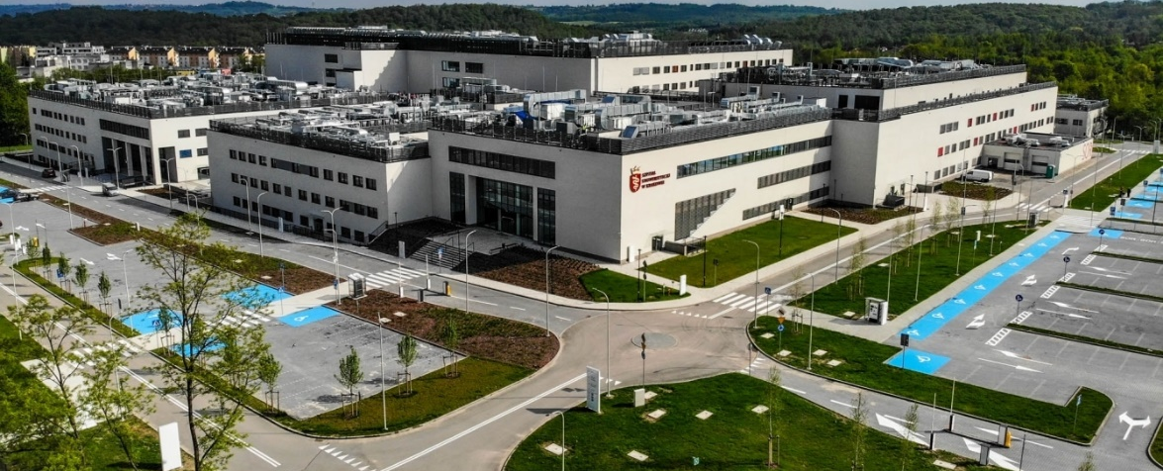

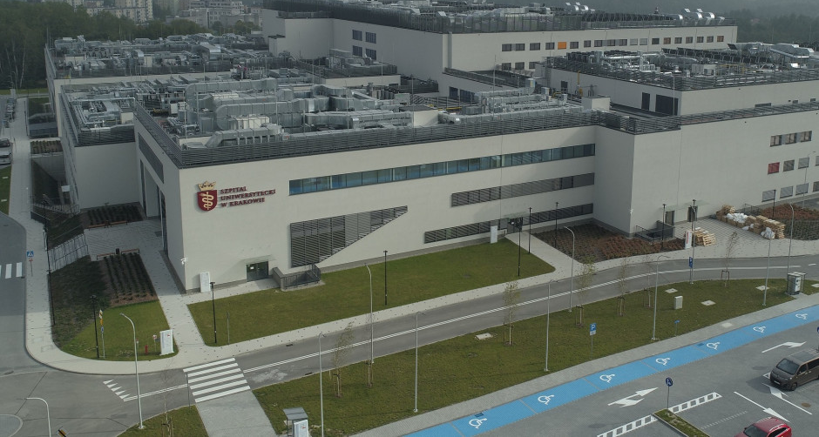

Next, walk forward along the corridor. Before reaching the next door, on your right you will find the elevator. Take it to the +3 floor, exit the lift and turn to the corridor on your left. There, you will find the entrance to the Operating Theatre.
Classes in the Operating Theatre will be held between 7.45 and 10.00 am.
Good luck!
1.Clinical Anesthesiology, G.Edward Morgan, Jr., Maged S. Mikhail, 5th Edition,
2. Advanced Life Support – guidelines //www.erc.edu/index.php/als_overview/pl
3.Basic Life Support and AED – Guidelines //www.erc.edu/index.php/bls_aed_overview/pl/

Due to the pandemic, there may be changes in the schedule of classes. We will try to inform you about the changes early
We apologize for any inconvenience

